SSEN Distribution Network

SSEN Distribution North (Scotland Including Highland and Inlands)
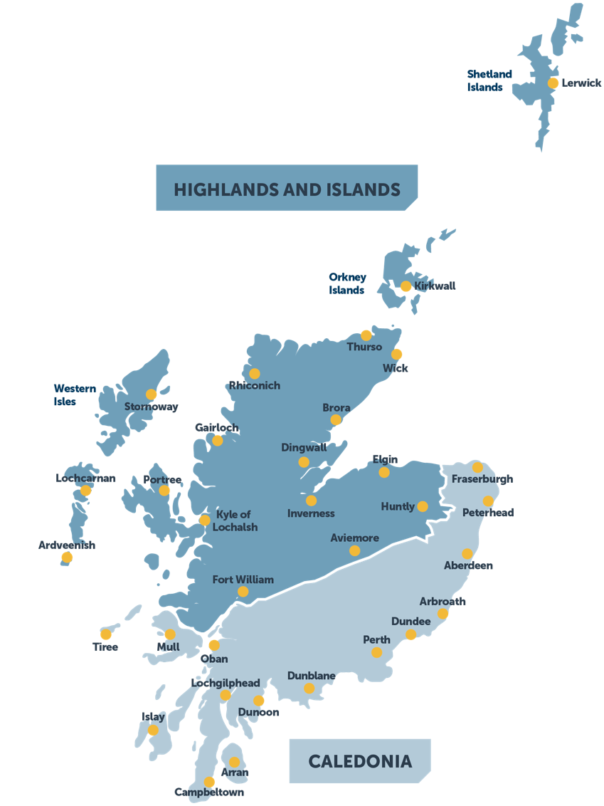

SSEN Distribution South Network Regions
