SSEN Distribution OHL Construction (up to 33kV) Framework

Pre-Qualification Questionnaire Overview and Instructions
Procurement Event Reference: FW Construction - Distribution OHL Works South (up to 33kV) - Multi Site 0333 (Jaggaer PQQ ref: 345)
Date 10/09/2024

Contents
1. Disclaimer 2
2. Introduction 4
Scottish & Southern Electricity Networks (SSEN) Distribution 4
Our 4 Priorities 5
Southern Electric Power Distribution (SEPD) 5
3. Overview 6
4. Delivery Approach 6
5. Anticipated base load Volumes 7
6. Framework Requirements 7
7. Scope of Agreement 8
8. Objectives of the Agreement 9
9. Allocation of works 9
10. Sustainability 10
Timing 10
11. Contract Principles Schedule 10

Disclaimer

Values quoted are indicative and shown for information only at this stage. Any costs or volumes included in this Pre-Qualification Questionnaire ‘PQQ’ (or shared separately) are subject to change at Southern Electric Power Distribution (SEPD) sole discretion. Further information upon volumes and other elements that remain in development, will be shared at ITT stage.

Please note that SEPD reserves the rights to:

- Modify the PQQ at any stage during the PQQ process. Any instruction to modify the PQQ will be issued to all Applicants simultaneously.
- Cancel the Procurement.
- Request that an Applicant provide additional information to supplement or clarify any of the information provided in its PQQ response.

Note: SEPD will accept no liability or responsibility for:

- The accuracy of the information or data contained within this PQQ.
- Any costs associated with the preparation of any Applicant’s response to this PQQ and/or associated activities, including but not limited to the extension of time limits and/or cancellation of the Procurement.

Introduction

Scottish & Southern Electricity Networks (SSEN) Distribution
We are the electricity Distribution Network Operator (DNO) responsible for delivering power to 3.8 million homes and businesses across central southern England and the north of Scotland. We serve some of the most diverse and unique geographies across the UK, and keep customers and communities connected whilst developing the flexible electricity network vital to achieving net zero.

Our network serves some of the UK’s most remote communities and some of the most densely populated. Our two networks cover the greatest land mass of any of the UK’s DNOs, covering 72 local authority areas and 75,000km² of extremely diverse terrain.

Our 130,000km of overhead lines and underground cables, and 106,000 substations, are managed by more than 3,700 direct employees including skilled engineers, customer service teams and future energy experts, many of whom live and work in the communities they serve.

By enabling a smarter, more resilient electricity network, we’re ensuring local communities from west London to Aberdeen continue to receive the reliable power they need. The five years from 2023 will be transformative for the UK’s energy sector, and we’re committing to an ambitious work programme that will deliver real and valued benefits during and beyond RIIO-ED2.

More information can be found in our RIIO-ED2 Business Plan.

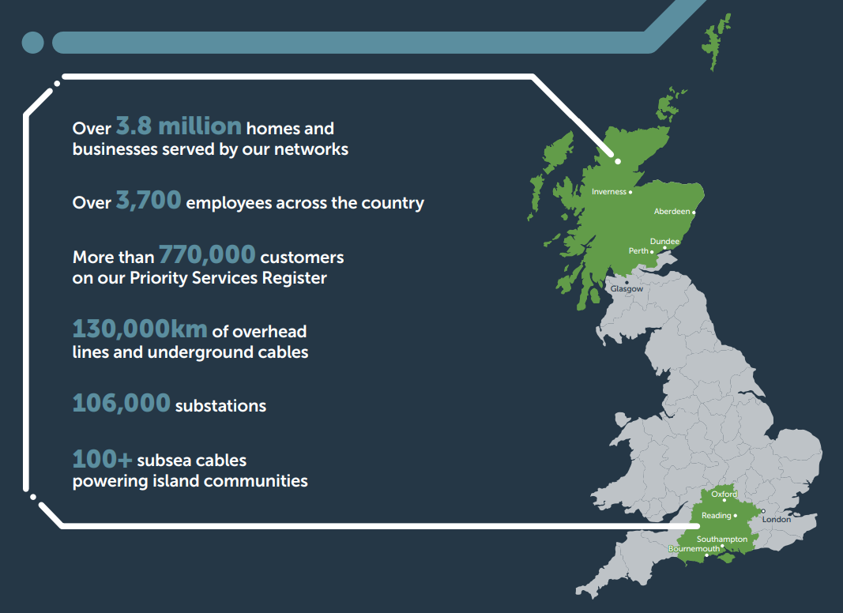
Figure 1 – SSEN Distribution License Areas

Our 4 Priorities
- Deliver a safe and resilient network that meets our customers’ needs and that supports the greater electrification of heat and transport.
- Provide a high quality, value-creating and trusted service for our customers and communities that evolves with their needs and expectations.
- Accelerate the progress toward, and enable all customers to participate in, a net zero world.
- We will make a positive impact on society by doing even more for our communities and environment.

Southern Electric Power Distribution (SEPD)
SEPD is the Distribution Network Operator in our southern license area. Over 7 million people live and work in our central southern England network, which serves 3.1 million homes and businesses and has the highest concentration of UK headquarters of global companies outside of London. This region is one of the most culturally diverse areas in the UK, with over 150 languages spoken and considerable population growth anticipated over the coming decade.

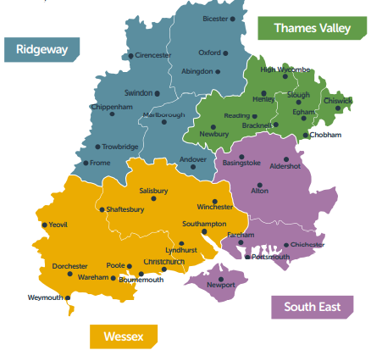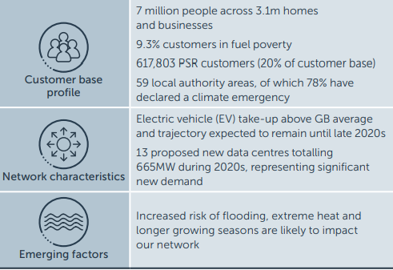

Overview
SEPD (The Authority) intends to award a framework agreement for the construction, maintenance and dismantlement of overhead lines (OHL) and poles on networks up to and including 33kV. This framework agreement will represent a step change for SEPD and as such, will require the highest levels of Supplier professionalism, collaboration and flawless work execution. The procurement is subject to the Utilities Contracts Regulations 2016 and procurement procedure being used is the Negotiated Procedure with Prior Call for Competition.
We are seeking long-term strategic partners to deliver our ambitious RIIO-ED2 Business Plan and to plan and execute work into RIIO-ED3, play a significant role in our transition to net-zero and deliver great outcomes for our customers by driving efficiency through innovation, development of new technology and products, development of skills and supporting the growth of a locally sourced skilled workforce within our sector. This strategy is underpinned by the intention to award frameworks based on the geographical lotting (as set out below) and committed volumes, removing the need for mini competition, to provide commitment to our delivery partners to facilitate growth.

The Authority will use the information provided in response to this PQQ to make an assessment of the Supplier’s economic and financial standing and technical and professional ability in order to decide who will be invited to tender for the framework agreement. The Authority’s intention is to arrive at a Short List of up to 10, subject to also achieving a minimum overall score of 60/100 to be considered for the Tender Stage. The Authority reserves the right to adjust the minimum score requirement subject to the standard of responses received. In the event more than 10 potential Applicants achieve a score higher than 60/100, the top scoring 10 potential Applicants shall be short listed. The Authority reserves the right to increase the number of suppliers prequalified at its discretion. The Authority will evaluate PQQ responses in line with the Selection Criteria.

Delivery Approach
SEPD recognises the need to evolve our approach to deliver in response to the needs of our consumers and the dynamic needs of the industry, enabling the transition to Net Zero. We anticipate that future delivery needs within the industry, skills shortages, and load growth (which is likely to accelerate) requires a flexible delivery model. We understand we cannot deliver the growth alone – we need a more collaborative approach for flexibility, efficiency, resilience, and innovation.

The premise of our delivery approach is in response to the needs of the market - we recognise the constraints on the industry from skills to materials. To support growth, we aim to make volume commitments to the market with respect to the construction, repair, maintenance and dismantlement of overhead lines and poles on Distribution Networks up to and including 33kV.

This delivery approach will capitalise on potential synergies and strategically planned Load and Non-Load work with the aim to maximise outage utilisation enabling the programme to touch the network in a controlled and efficient manner.

Note: SEPD reserves the right to remove certain activities, requirements or projects based on network requirement, risk, or specialist products or works. SEPD will also free-issue key materials. This will be confirmed at tender stage.

Anticipated base load Volumes
Pole changes and associated maintenance (estimated)

Voltage | Ridgeway | Southeast | Thames Valley | Wessex | Total
33kV | 100 | 50 | 50 | 100 | 300
11kV | 1000 | 500 | 500 | 1000 | 3000
LV NI’s | 133 | 66 | 66 | 133 | 398
ABC* |  |  |  |  | 100km
*est 7 pole changes per km
*FY24/25 – Wessex & THV and FY 25/26 Ridgeway and Southeast.

Financial Year | Ridgeway | Southeast | Thames Valley | Wessex
2025-26 | 61 | 74 | 23 | 35
2026-27 | 51 | 59 | 64 | 93
2027-28 | 59 | 46 | 64 | 72
2028-29 | 66 | 53 | 77 | 85
2029-30 | 54 | 51 | 45 | 42
2030-31 | 69 | 42 | 29 | 69

Framework Requirements
  - The Authority requires Contractor(s) to provide relevant planning and access arrangements and complete the construction, maintenance and dismantlement of overhead lines and wood poles on networks up to and including 33kV. The geographical spread associated with this Framework covers the South Distribution network, namely the Thames Valley, Ridgeway, Wessex, and South East Regions.
  - In addition to OHL Works, there may, from time to time, be a requirement to provide additional services including underground installation of cable, jointing, traffic management, LV tree cutting, excavation and reinstatement.
  - Under this Contract, there will be an expectation that the Contractor will provide their staff to assist with repairs to the OHL network due to adverse weather. The Contractor will make available their normal resource level.
  - Framework Agreements will be awarded to a maximum of five Contractors, utilising the NEC3 Term Service contract under the laws of England and Wales. The Authority, however, reserves the right to increase the number of Contractors appointed to the Framework in order to secure resource levels commensurate with required outputs. The anticipated contract duration is 5 years with a further 3 x 1-year optional extensions.

Scope of Agreement

  - An overview of the elements of scope contained within this agreement is noted below and is based on what is included in our RIIO-ED2 Business Plan submission to Ofgem.

High level scope of work
- Construction, maintenance and dismantlement of OHL on networks up to and including 33kV.
- Where required as part of a wider OHL scheme, provision of additional services to cover underground installation of cable and civil works.
- Act as both Principal Designer where required and Principal Contractor under CDM Regulations 2015.
- Design feasibility to SSEN policies and standards.
- Engineering optioneering, validation, refinement and execution of the works.
- Comprehensive construction activities including, installation, commissioning, dismantling and disposal.
- Management of necessary access requirements and negotiations to ensure the works can be completed.
- Identification of all land designation, including magic map searches to ensure compliance with ISO14001 and environmental regulations as a statutory undertaker.
- Negotiation of network access with SEPD including outage planning and requests.
- Interface management and negotiation with external stakeholders including Local authorities, landowners, and customers; both commercial and domestic.
- Planning, scheduling, and managing pre-construction and post construction activities and compliance with associated legislative and regulatory duties e.g., CDM2015, HSE etc.
- Value-engineering and innovation to propose changes and ideas that reduce costs/schedule while maintaining or enhancing design intent and quality, value, and functional performance of improvements. Assist in the development and implementation of value engineering and innovative ideas.
- Support the resolution of project interfaces and dependencies.
- Safe by design, incorporating safety principles in design construction and maintenance in accordance with relevant legislation.
- Activities as required during storms and other times.

Objectives of the Agreement
Considering the Distribution ED2 Business Plan stakeholder-led goals; the key objectives of the agreement shall be:

Safety, Health & Environment:
- To choose partners that share our commitment to that we all get home safe, jointly setting high standards
- To have no life changing injuries or major safety, health, and environmental incidents
Delivery
- To ensure delivery of the services and works associated with the Delivery programme
- A collaborative, strategic and long-term client contractor partnership relationship
- Provide visibility of work to partners to allow effective network and resource planning
- To facilitate enduring key skills development and industry retention
Efficiency
- To achieve year on year cost improvements.
- Innovation: support and reward the implementation and embedding of best-in-class innovation that delivers tangible benefits
Customer Service
- Fewer interruptions: to develop and optimize delivery of projects to reduce number of planned customer interruptions
- Customer Satisfaction: Ensure works and contract partners contribute to customer satisfaction targets as defined by Ofgem.
Net Zero/Sustainable Supply Chain
- Sustainable Supplier Code: implementation of a clear targeted pathway to Net Zero Outperformance of Sustainable Supplier Code.
- Demonstrate the supply chain contribution to Distribution reporting (including SBTs) and reduction in our Embodied Carbon (Scope 3 emissions/suppliers’ Scope 1 and 2)), a reduction in waste, and examples of innovation.

Allocation of works

Agreements shall be awarded to a maximum of five bidders. The Agreements shall be lotted as follows (potential bidders may apply for single, multiple or all Lots):

Lot 1 Ridgeway Region
Lot 2 South East Region
Lot 3 Thames Valley Region
Lot 4 Wessex Region

SEPD reserves the right to award one or more lots together depending on the outcome of the tender. Award will be dependent on resource coverage; the Authority reserves the right to award Agreements to an appropriate number of suppliers to guarantee the required resource levels. The award criteria and lotting strategy will be further defined in ITT.

Sustainability
In line with the UK’s transition to a net zero economy and SEPD’s Sustainability Strategy, SEPD recognises that our sustainability and environmental performance has a dependency on a sustainable supply chain. Contained in the agreement will be a Sustainable Supplier Code (SSC), which has been built based on SEPD’s key UN Sustainable Development Goals (SDGs), where we assessed which of the key SDGs are most relevant to supply chain activities, alongside similar activity that we were involved in to support SSE Group’s sustainable procurement approach. Therefore, we have based the development of the SSC on the 12 core themes associated with the key SDGs.

For example, one key requirement is that throughout RIIO-ED2 our target is to have 80% of our supply chain (by spend) signed up to our Sustainable Supplier Code, and we will continue to maximise the number of suppliers compliant with the code with the aspiration to reach 90% by the end of RIIO-ED2. Another example is one of our code requirements, that by the end of the ED2 price control period, in relation to Scope 3 emissions targets 35% of the supply chain (by spend value) will have committed to setting science-based targets (SBTs) by 2026 (with a target of 55% by 2033).

Timing
On conclusion of the PQQ scoring and notification the aim is to issue the ITT by the end of November 2024, with a view to awarding the agreements by the end of March 2025.

Contract Principles Schedule

We have included a schedule to provide clear guidance on the principles that underpin our draft contract provisions; the final positions for each will be shared at the Invitation to Tender (ITT) stage.

SEPD intends to utilise the PQQ stage to continue to capture supply chain feedback on key elements, to enable further development of the agreement in readiness for the ITT. Supply chain engagement and a collaborative approach, listening to those who know best to shape this agreement will be key for our future partnership.

Applicants should note:

- Any feedback shared within PQQ submissions that is related to the development of SEPD requirements for ITT stage, will not be scored during PQQ evaluation and is for information-only at this stage; and

- The Contract Principles are shared with Suppliers as part of the PQQ stage without prejudice and subject to contract; and

- The items listed in the Contract Principles are non-exhaustive.

- Scope of the Agreement
This significant programme of work amalgamates several scopes of work on the OHL network including (but not limited to) OHL replacements, construction, dismantlement, maintenance, refurbishment, wayleaves, ABC and works associated with jointing, substations, cabling, and civil works
- Conditions of Contract
The NEC3 suite of contract forms will be used. The terms and conditions will be based on the existing suite of SSE Group NEC3 standard templates.

- Duration/Term
The agreement duration shall be 5 years plus optional 3 x 1 year extension periods.

- Increase of Works
The agreement is intended to include mechanisms for a committed volume of work over the initial period, with a flexibility mechanism to accommodate an increase in workload within the awarded regions due to impacts of Net Zero growth, Ofgem and Uncertainty Mechanism.

- Call-off Competition Procedure
Given the committed volumes strategy, the call-off procedure will be direct allocation. SEPD, however, will retain the right to mini-compete across regions or award outside of the framework if a supplier is demonstrably failing to perform in accordance with the contract.

- Visibility of Programme to Supply Chain Partners
The agreement will be awarded based on volume known at the time of execution, with adjustments (for non-baseload volume, including but not limited to Uncertainty Mechanisms). The jointly constructed programme(s) will be of high importance for this contract and will include detailed planning, scheduling and integration of the activities necessary to ensure the performance and completion of the work. These programmes will be managed collaboratively using robust change control processes embedded in the agreement.

- Design Responsibility
As Principal Designer under CDM 2015, you will be responsible for the validation and refinement stage of the works, ensuring all works are fully accessed and compliant before moving into the construction phase of the project. This will require engagement with all stakeholders both domestic and commercial, including government bodies such as DESNZ, MOD and Natural England. In some cases, you will need to onboard land agents to support with your access negotiations. Once the validation stage is complete the works will be assessed at call-off with the Employer.

- Performance Specification
SEPD will develop a performance-based specification which shall set out the high-level requirements for delivery of Programmes of work under this agreement.

- Risk Management
We aim to build a constructive and collaborative approach to managing commercial and delivery risks at portfolio, programme, and project levels. A core principle will be seeking to equitably allocate lead responsibility across key risk categories, to the parties who are best placed to manage and mitigate those risks.

- Incentivisation
Notwithstanding the cost model and rate structure, Delivery Partner incentivisation is essential to drive commercial performance and meet the required level of efficiencies. This will be shared at ITT stage but relates to progress versus plan, efficiencies of outages and reductions in mobile generation costs.

- Key Performance Indicators (KPIs)
Key Performance indicators are required as part of the framework management. The NEC3 approach with KPIs is to promote the concept of continuous improvement. Each KPI will be identified and described, including achievement criteria, in the draft agreement to be incorporated within the ITT documents and will be closely linked to the Incentivisation provisions.

- Performance Guarantees and Bonds
It is intended that a programme-level retention bond will be applied as part of the agreement. An on-demand performance guarantee bond will be required at portfolio level and if appropriate, a parent company guarantee (PCG) may also be required.

- Limitation of Liability
Liability provisions are to be included within the agreement and will be further developed in line with our approach to Risk Management and the Allocation of Work.

- Defects
Defects Liability periods will be advised at ITT stage.

- Contract Price Adjustments
SEPD understands the current market conditions and therefore a Contract Price Adjustment mechanism is to be applied, this will likely cover raw materials and labour and will seek to back-to-back with Ofgem’s price adjustment mechanism.

- Supplier Relationship Management
It is intended that SSE Group’s existing SRM model will be implemented for these agreements; hence utilising existing, proven procedures and resources to support successful collaborative implementation.

- Storm Support
To ensure we can always deliver for our customers, The agreement shall include the provision for the contractor to provide an equivalent level of operational resources during storms as during normal periods, with responsibilities and timescales in line with existing processes to cover the SEPD region.

- Fault Support
To ensure we can always deliver for our customers, The agreement shall include the provision for the contractor to provide fault support when required

- GDPR Clauses
Due to the requirement to share highly confidential customer data to enable delivery of the scope of this agreement, note that at ITT stage SEPD will include the required GDPR-based contract clauses that will reflect all of the requirements with respect to handling all data.

- Insurance
Working with the SEPD insurance department, preferred specific insurance requirements (which may include the option for SSE Group Owner Controlled Insurance Policies) will be shared at ITT stage, where supply chain partners will be able to confirm their preferred approach.

- Termination
NEC3 with amendments in line with SSE Group standard provisions.

If you wish to participate in the PQQ process, please contact Deborah Johnstone for further information deborah.johnstone@sse.com

